[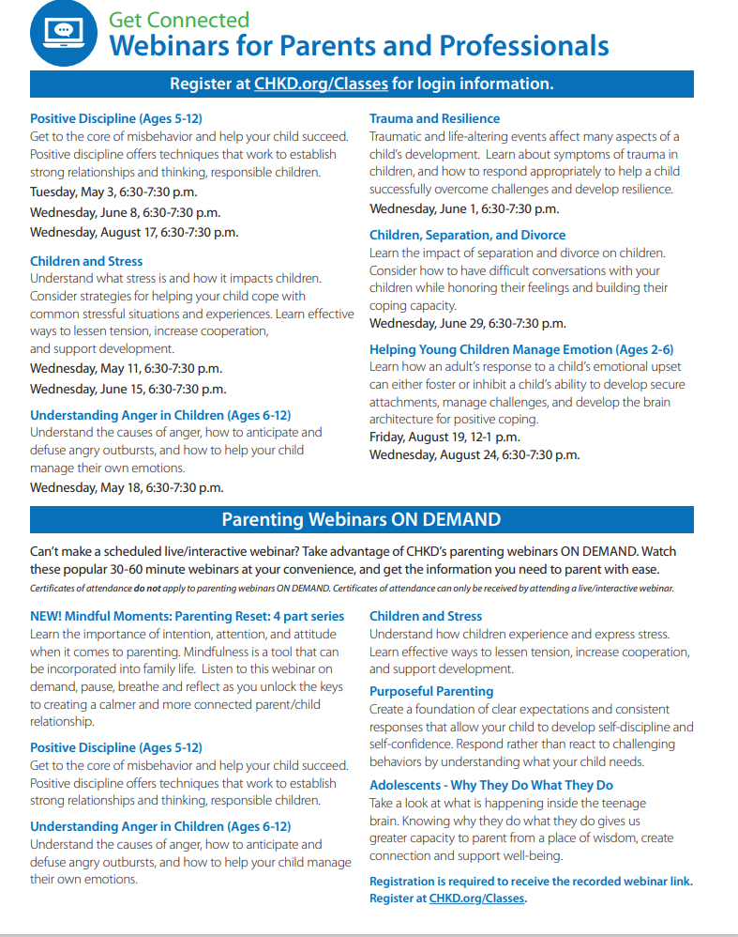](https://www.chkd.org/Patients-and-Families/Parenting-Classes-and-Resources/)