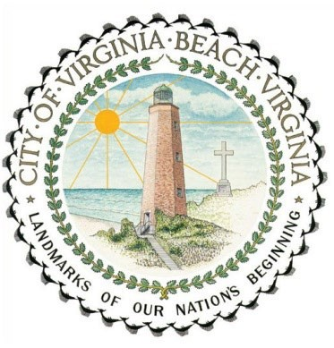
Virginia Beach Water Assistance Program

The purpose of the program is to: Prevent water service disconnection
Re-connect water service
Assist customers with minor plumbing repairs

Program Eligibility Requirements

- Must be an active residential water service customer of Virginia Beach Public Utilities and applicant must reside at the property in question. Cannot be used for HRSD bill.
- The bill does not have to be delinquent. It can cover multiple outstanding bills.
- Bill must be in the applicant’s name. Authorized users for accounts are not eligible.
- An applicant/account can only qualify for assistance once per fiscal year (July 1 to June
30. Cannot be used to cover the first bill on an account.
- Maximum payment of $300 per occurrence for a City Services Bill (“Water Assistance”); $250 for a plumbing repair (“Plumbing Assistance”).
- Assistance payment must fully satisfy all bills that are due (or overdue) at the time of receiving an assistance payment. Applicants will be required to pay down any amounts in excess of $300 before becoming eligible for an assistance payment.
- Assistance payments may be used toward balances that include late payment charges and delinquency fees, but cannot cover account setup, tampering, pulled meter, or meter lock fees.
- Customer must pay any administrative fees (such as account setup or returned check fees) prior to being eligible for assistance.
- Must meet income guidelines (shown below).
Available financial resources cannot exceed $2,000.
2021 Income Thresholds*
Persons in family/household | Water Assistance Program Water Assistance Program  Annual Income Monthly Income
1 | $28,980 | $2,415
2 | $39,195 | $3,266
3 | $49,410 | $4,118
4 | $59,625 | $4,969
5 | $69,840 | $5,820
6 | $80,055 | $6,671
7 | $90,270 | $7,523
8 | $100,485 | $8,374
For families/households with more than 8 persons, add $4,540 annually or $378 monthly for each additional person. Income levels apply to all household members 18 years and older.
*Equates to 225% of Federal Poverty Guidelines

Effective 06.28.2021

Plumbing Repairs:
- Property must be an owner-occupied residence.
- Repair must be done by a licensed plumber/plumbing company (by the Virginia Department of Professional and Occupational Regulation Board for Contractors).
- Bill must be itemized for work completed at applicant address.
- Plumbing bill must include: company name, address, telephone, and valid business (Contractor’s) license number.

Application Disqualifications
- Submitting false information will result in denial and makes the applicant ineligible for that fiscal year; a second offense will make an applicant ineligible for two years; a third offense will permanently ban the applicant from the program.
- No tampered meter activity or illegal connections. Applicants with tampering fees, pulled meter fees, locked meter fees, must pay these fees to be eligible.

Required Documents
Water Assistance Plumbing Assistance

- Copy of the Virginia Beach City Services • Copy of the itemized plumber’s bill
Bill
- Verification of current income (all • Verification of current income (all household members 18 years and older) household members 18 years and older)
- Bank statement(s) * • Bank statement(s)*
- Virginia Beach Water Assistance Program • Virginia Beach Water Assistance Program
Application Application
*Applicant must submit a complete statement for all accounts (checking, savings, investment, retirement accounts) with any and all financial institutions, including banks, credit unions, retirement funds, investment, and brokerage institutions.

Payment Procedures
All balances in excess of $300 must be paid by certified funds, in the form of cash, money order, or cashier’s check. Customer must provide receipt and/or receipt number to the Department of Human Services by fax, e-mail or phone upon completion of balance pay down before eligibility can be determined.

Water Assistance Program Contact Information
Program application and eligibility are determined by the Department of Human Services. The Water Assistance Program staff can be reached at 385-6700. Effective 06.28.2021

