Queen Esther’s Crown Craft
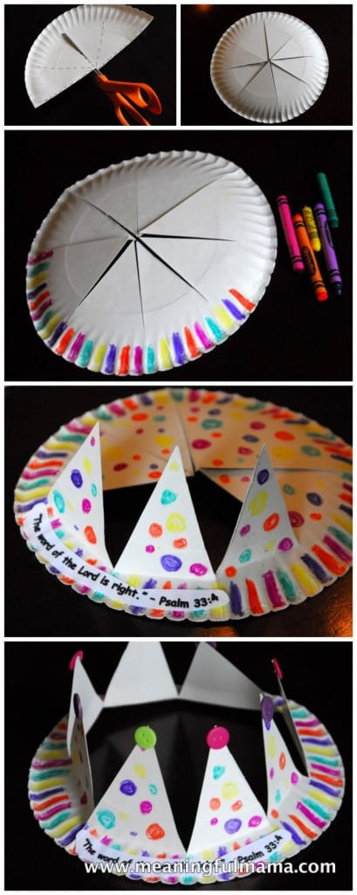
Supplies:
Paper Pale
Scissors
Glue
Markers
Markers, stickers, hot glue gun, buttons

- Fold the paper plate in half and cut into fourths, like a pizza, without cutting all the way to the edge.
- Open up the plate to make the last two cuts.
- Color and decorate the crown. Add any embellishments, such as stickers or glue.
- When you are done decorating, fold the triangles up in place. Wear and enjoy!

